DAA Assignment -2

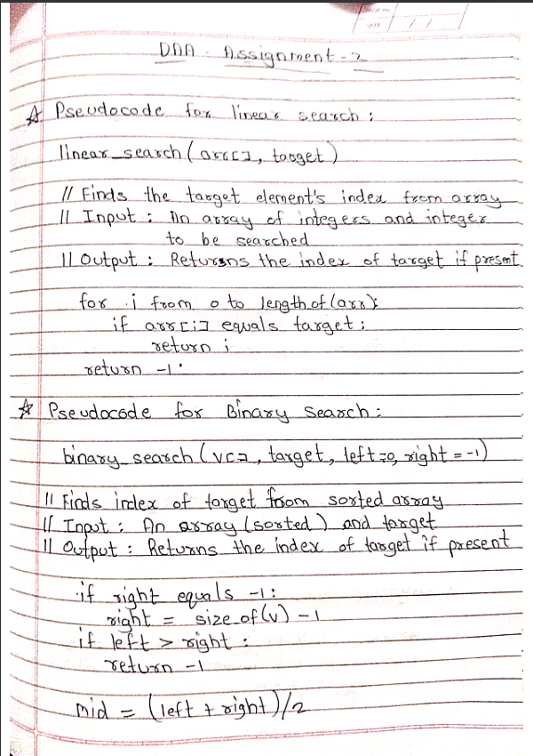

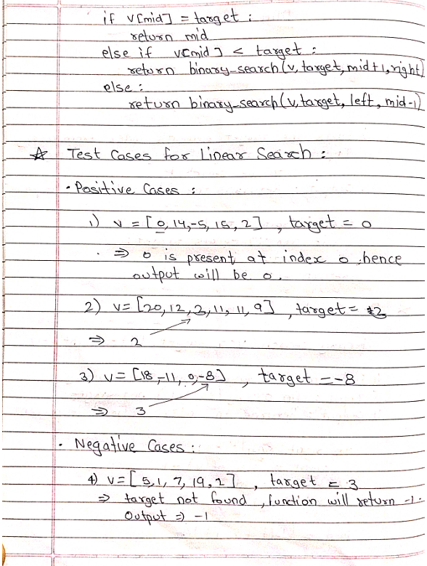

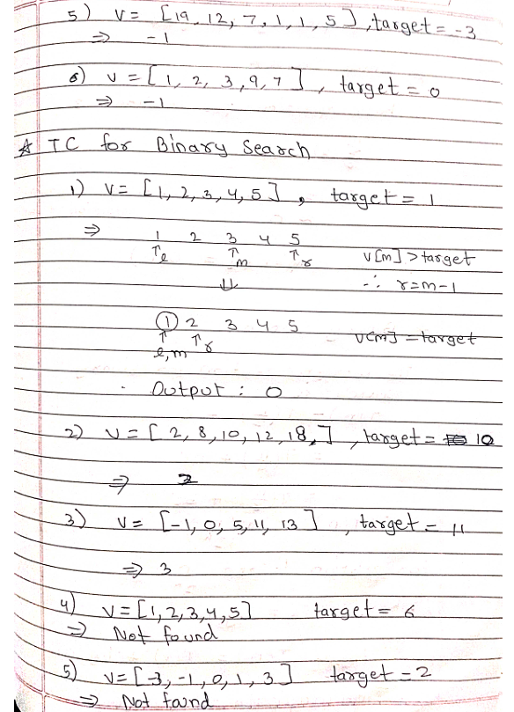

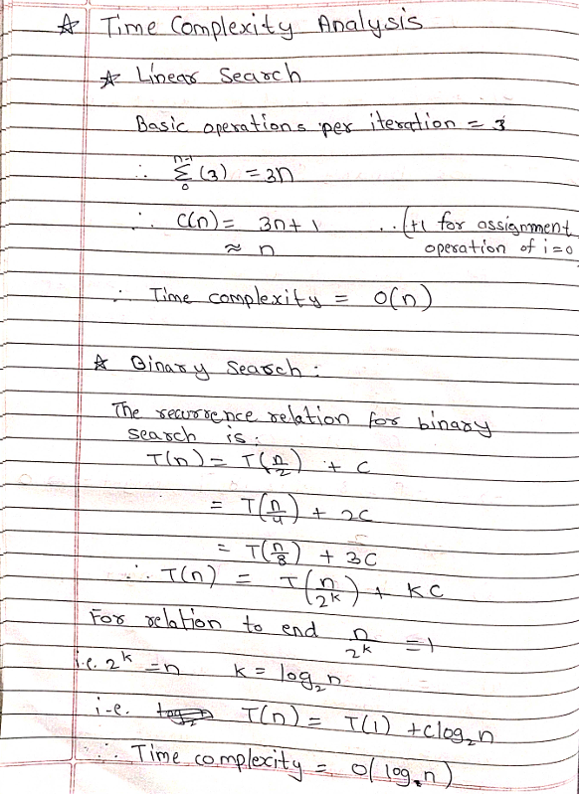

**Code for linear search:**

int linear_search(vector<int> v,int target){

for(int i=0;i<v.size();i++){

if(v[i]==target){

return i;

}

}

return -1;

}

**Code for binary search:**

int binary_search(vector<int> v, int target,int left=0,int right=-1){

if(right==-1){

right=v.size()-1;

}

if(left>right){

return -1;

}

int mid=left + (right - left)/2;

if(v[mid]==target){

return mid;

}

else if(v[mid]<target){

return binary_search(v,target,mid+1,right);

}

else{

return binary_search(v,target,left,mid-1);

}

}

**Testing the program:**

**For Linear Search:**

**Positive cases:**

Test 1:



Test 2:



Test 3:



**Negative Cases:**

Test 4:



Test 5:



Test 6:



**For Binary Search:**

**Positive cases:**

Test 1:



Test 2:



Test 3:



**Negative Cases:**

Test 4:



Test 5:



Test 6:



**Conclusion:**

The conclusion of this study of linear search and binary search is that linear search is efficient to search the particular target from unordered data but if the given data is sorted in some order we can use binary search to find the target data.

Also we studied the time complexity of both the searches and coding style for C++ language.